Rogue Device Detection Using Passive Network Traffic: A Behaviour-Driven, Self-Healing Approach with Per-Device Risk Scoring

A Mini Project Report Submitted in partial fulfillment of the requirements for the award of the degree of

BACHELOR OF TECHNOLOGY
In

DEPARTMENT OF COMPUTER SCIENCE AND ENGINEERING
By
Y.V. Vasu – 2320030400
S. Pradeep – 2320030412

Under the Esteemed Guidance of
Dr. K. Swanthana , Associate Professor, Department of CSE





K L (Deemed to be) University

DEPARTMENT OF COMPUTER SCIENCE AND ENGINEERING

DECLARATION

The mini-project report entitled “Rogue Device Detection Using Passive Network Traffic”
is a record of bona fide work carried out byVenkata Vasudeva Reddy Yeddula (2320030400) and Shivarathri Pradeep (2320030412) in partial fulfillment of the requirements for the award of the B.Tech degree at K L (Deemed to be) University. The work presented in this report is original to the best of our knowledge, and all datasets, tools, code, and external sources used have been appropriately acknowledged.

Venkata Vasudeva Reddy Yeddula (2320030400)
Shivarathri Pradeep(2320030412)
K L (Deemed to be) University

DEPARTMENT OF COMPUTER SCIENCE AND ENGINEERING

CERTIFICATE

This is to certify that the mini-project report entitled “Rogue Device Detection Using Passive Network Traffic” is a bona fide work carried out by Venkata Vasudeva Reddy Yeddula (2320030400) and Shivarathri Pradeep (2320030412) under the supervision of Dr. K. Swanthanaduring the academic year 2026-2027 in partial fulfillment of the requirements for the award of the Bachelor of Technology degree at K L (Deemed to be) University.

Signature of the Project Supervisor

Signature of the HOD Signature of the External Examiner

ACKNOWLEDGEMENT
The success in this project would not have been possible but for the timely help and guidance rendered by many people. Our wish to express my sincere thanks to all those who has assisted us in one way or the other for the completion of my project.

Our greatest appreciation goes to our guide, Dr. K. Swanthana, Associate Professor, Department of Computer Science and Engineering, for her tremendous support, encouragement and guidance throughout this project.

We express our gratitude to Dr. P.Venkateshwar Sir (CSE)/Dr. Kaja Shareef Sir (CSIT)/Dr.Sreenath, Head of the Department for Computer Science Engineering/ Department for Computer Science and Information Technology/ Department Of Artificial Intelligence And Data Science for providing us with adequate facilities, ways and means by which we are able to complete this project-based Lab.

We thank all the members of teaching and non-teaching staff members, and also who have assisted me directly or indirectly for successful completion of this project. Finally, I sincerely thank my parents, friends and classmates for their kind help and cooperation during my work.

Venkata Vasudeva Reddy Yeddula – 2320030400
Shivarathri Pradeep – 2320030412

TABLE OF CONTENTS

S.No. | Contents | Page no.
1. | Abstract
2. | Introduction
3. | Literature survey
4. | Problem Statement and Objectives
5. | Hardware and Software requirements
6. | Implementation
7. | Results & Discussion
8. | Conclusion & Future Scope
9. | References

ABSTRACT

Home and campus local-area networks host laptops, phones and IoT devices, and a single rogue or compromised device can operate unnoticed for long periods. Signature-based intrusion detection and static firewall rules recognise only known patterns, overlook gradual behavioural drift and need manual intervention once a threat is flagged. This project builds a behaviour-driven, self-healing network security prototype using passive monitoring, in the domain of network security and IoT. Traffic comes from a synthetic traffic simulator; a Scapy-based live sniffer is implemented but not yet evaluated. For each device and time window, five features are extracted: packet rate, unique destination IPs, unique destination ports, DNS query count and connection count. A per-device baseline is learned online with Welford’s algorithm over six windows, and a rule-based 0–100 risk score expresses deviation, with a human-readable reason for every point. Devices that cross the threshold are isolated, then re-evaluated and restored once behaviour normalises. Evaluation was qualitative. In a reproducible 90-second simulation with three known devices and one injected rogue device, the rogue scored 60–100 and reached the critical score of 100, triggering an isolation action logged in dry-run mode, while known devices mostly stayed in the normal range. All eight unit tests pass. A short baseline window caused some false positives on a legitimate device. No accuracy, precision, recall or F1 is claimed. The work offers a lightweight, interpretable basis for LAN protection.

Team Name: 14

Team Members and Responsibilities:

- Venkata Vasudeva Reddy Yeddula , 2320030400 – team lead/execution
- Shivarathri Pradeep, 2320030412 – team member/data source
- repository URL - https://github.com/vasuyeddula/Capstone-project-1

INTRODUCTION

Modern home and campus local-area networks (LANs) host a heterogeneous mix of laptops, smartphones and Internet-of-Things (IoT) devices. In such an environment, a single compromised or rogue device can scan the network, exfiltrate data or join a botnet long before an administrator notices. Reviewing raw network traffic by hand does not scale: a busy LAN produces thousands of packets per second, and the signs of misbehaviour (a sudden fan-out to many hosts or ports, a burst of DNS lookups) are buried in normal traffic. Rule-based and statistical analysis can learn what is normal for each device and highlight deviations automatically.
The target users are network administrators of home, campus and small-office networks, IoT gateway operators and security-operations teams who want a dashboard that points to the devices that need attention. The input is passive network traffic (packet events observed on a mirrored or monitor-mode interface, or from the simulator) and the output is, for every device, a 0–100 risk score, a status (normal, suspicious, high_risk or critical), the reasons behind the score and a response action (isolate or restore).
The proposed pipeline has five stages: passive capture, feature extraction, per-device baseline learning, rule-based risk scoring, and automated response. Scores and alerts are stored in SQLite and shown on a live Flask dashboard. Nothing is ever sent to or probed on a device, which makes the approach non-intrusive.
The rest of this report is organised as follows. Section 3 reviews related work and the research gap. Section 4 states the problem and objectives. Section 5 lists the hardware and software requirements. Section 6 describes the implementation. Section 7 presents results and discussion. Section 8 concludes with future scope, and Section 9 lists the references.

LITERATURE SURVEY

Ten sources were reviewed. Each summary covers the problem, method, evaluation, main finding and limitation. Reference numbers refer to Section 9.
1. Meidan et al., N-BaIoT (2018) [1]. The work detects IoT botnet attacks by training deep autoencoders on 115 statistical traffic features. It works on a fixed offline dataset and outputs a binary or multi-class label. The main finding is that learned models can detect botnet traffic from IoT devices. Limitation: the model is global and offline, and it stops at a label, with no graded score and no response.
2. Neumann, Heen and Onno (2014) [2]. The paper identifies wireless devices from global traffic parameters in 802.11 captures taken in office and conference settings. Parameters include inter-arrival time, transmission time and medium-access time. Inter-arrival time was the strongest passive signal. Limitation: it only identifies devices and does not score behaviour.
3. Prasad, Biju, Somani and Mitra (2023) [3]. The authors model phase-based behavioural patterns of IoT devices behind a gateway on a testbed. Phase modelling identified devices with high accuracy. Limitation: it is fingerprinting only, with no risk score or automated response.
4. Early-stage IoT device identification (2026) [4]. The study shows that devices can be identified from very short observation windows using timing, packet-size and DNS-metadata features on lab IoT captures. Strong identification was possible within seconds. Limitation: it concentrates on early identification, not on ongoing behavioural risk.
5. Identification of IoT devices using neural networks and passive DNS traffic (2025) [5]. A neural network classifies device types from passive DNS traffic without payload inspection and reports high accuracy. Limitation: it classifies device type and does not assess multi-factor risk.
6. From flows to functions (2025) [6]. Service-level (port-based) fingerprints are evaluated on roughly ten million IPFIX flow records from 13 device types. The fingerprints are lightweight and explainable compared with per-packet machine learning. Limitation: no integrated risk score or response engine.
7. Trackly (2026) [10]. A user-behaviour analytics platform that flags anomalies through rule-based mismatch checks on device and session attributes, without machine-learning overhead. Limitation: it raises only a binary flag and has no graded 0–100 score.
8. SecuNet-4D (2025) [7]. The framework combines graph-neural-network anomaly detection with self-healing failover in an SDN simulation, and reports better accuracy and resilience than single-layer models. Limitation: it works at controller level and does not baseline individual devices.
9. GeckoNet (2024) [8]. A self-healing SDN framework that detects, isolates and recovers faults on an emulated topology. It shows that automated correction of network anomalies is feasible. Limitation: it targets infrastructure faults rather than the behaviour of individual endpoints.
10. Fingerprint merging and risk-level evaluation, U.S. Patent 10,320,825 [11]. The patent merges multiple anomaly fingerprints into a single risk-scored event with feedback-updated metrics. It shows that dynamic risk scoring is feasible. Limitation: enterprise and patent scope, not an open academic LAN framework.
Three further surveys on automated response were consulted for context: AI-driven threat detection and response in cloud security [12], self-healing AI-driven networks [13], and a taxonomy of security automation in SDN [14]. They report that automated isolation and recovery shortens manual response time, and that self-healing solutions remain less mature than reactive detection.

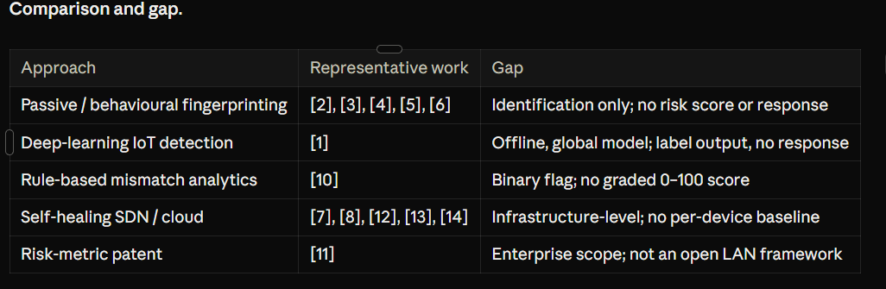

Fingerprinting work identifies devices, rule-based analytics raise binary flags, and self-healing work protects infrastructure. Among the sources surveyed, none fuses continuous per-device behavioural risk scoring with automated isolation and recovery. This project addresses that gap.

PROBLEM STATEMENT AND OBJECTIVES

Problem Statement:

To build a passive, behaviour-driven network security system that learns each LAN device’s normal behaviour, scores its deviation from 0 to 100 with explainable reasons, and automatically isolates and later restores high-risk devices.

Problem Description:
Signature-based IDS and static firewall rules recognise only known patterns. They miss gradual behavioural drift, do not separate a mildly unusual device from a dangerous one, and need manual intervention once a threat is flagged, leaving a window in which the device keeps operating. Home and campus networks rarely have staff to watch traffic continuously, so an automated, interpretable and non-intrusive approach is needed.

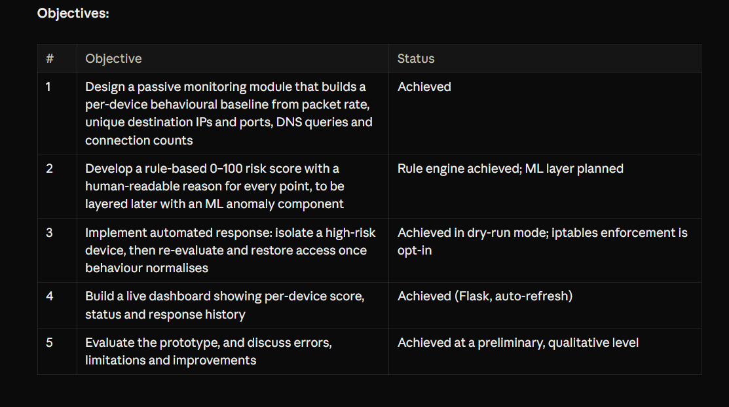

HARDWARE AND SOFTWARE REQUIREMENTS

Hardware Requirements:
- Computer or laptop with a modern multi-core CPU; 8 GB RAM or more is recommended.
- Simulation mode needs no root privileges and no network interface.
- For live capture: a network interface in monitor mode, or a switch port that mirrors LAN traffic, on a controlled testbed network.
- Sufficient disk space for the SQLite database, logs, configuration and result figures.
Software Requirements:
- Python 3 with the packages in requirements.txt.
- Scapy for passive packet sniffing (live capture backend) [15].
- Flask for the auto-refreshing dashboard [16].
- SQLite for storing devices, scores and alerts [17].
- pytest for the unit tests [18].
- YAML configuration (config.yaml) for thresholds and the known-device allowlist.
- Linux iptables, optional, only when real enforcement is enabled with the --enforce flag.
- Wireshark and Linux networking tools for testbed inspection.
- Git for version control.
All tools are free and open source.

IMPLEMENTATION

- Data and task: The task is per-device anomaly scoring rather than supervised classification, so there are no class labels and no train/test split. Input is a stream of packet events. In the experiments, the input comes from a synthetic traffic simulator that models a team laptop (AA:BB:CC:00:00:01), a phone (AA:BB:CC:00:00:02) and an IoT camera (AA:BB:CC:00:00:03), each with characteristic normal traffic, plus one rogue device (DE:AD:BE:EF:00:99) that is not in the allowlist and is injected about 15 seconds into the run. The rogue behaves like a port scanner issuing excessive DNS lookups. The data is generated by the project itself, so no third-party licence applies.

- NLP preprocessing and features: Feature Extraction and Baseline Learning. There is no text preprocessing. Instead, packet events are aggregated into per-device, per-window feature vectors; empty windows are handled explicitly. For each device and time window, five features are computed: packet rate, number of unique destination IPs, number of unique destination ports, DNS query count and connection count. For each device and feature f, a running mean and variance are maintained with Welford’s numerically stable online algorithm [9]. Given the n-th observation x:

δ = x − μ(n−1), μ(n) = μ(n−1) + δ / n
M2(n) = M2(n−1) + δ · (x − μ(n)), σ(n) = √( M2(n) / (n − 1) )

A device’s baseline is considered established after W = 6 learning windows. Because the update is incremental, no history is stored and the baseline adapts online without offline retraining. The baseline is fitted per device, so a device’s own history never leaks into another device’s baseline.

- Model training and evaluation Risk Scoring and Response
Once a baseline exists, each live feature value is converted to a deviation z(f) = (x(f) − μ(f)) / σ(f). The risk score is:
S = min(100, P_dev + P_allow + P_scan)
P_dev sums per-feature penalties that grow with z(f).
P_allow (+35 in our run) penalises a device that is absent from the known-device allowlist.
P_scan (+25) fires on a port-scan-like pattern, when the number of unique destination ports reaches a configured threshold.
Every contribution is logged with a human-readable reason. Scores map to four statuses (normal, suspicious, high_risk, critical) using thresholds read from config.yaml, not hard-coded.
When a device’s score crosses the isolation threshold, the response module isolates it. It re-evaluates the device periodically and restores access once behaviour normalises, closing the self-healing loop. By default the action is only logged (dry-run). Real enforcement through iptables rules is opt-in via the --enforce flag, which keeps experiments safe on shared networks.
- Project workflow and modules :
The prototype is a modular Python 3 package, so each stage can be tested and replaced independently.
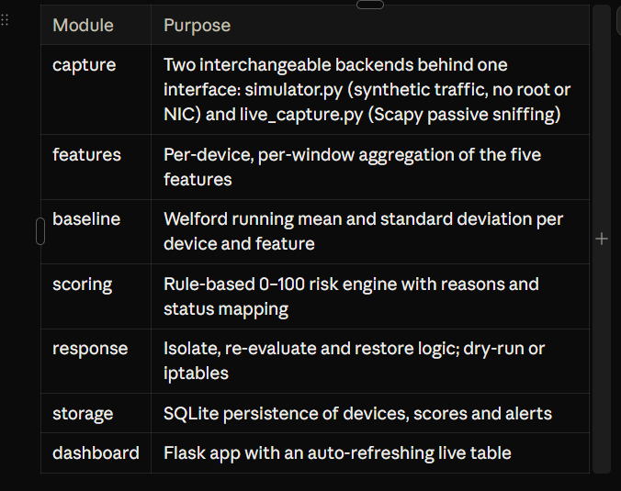

Testing:
Eight pytest unit tests cover per-device feature aggregation, packet-rate computation, empty windows, and the risk engine: normal traffic scores low, unknown devices are penalised, port-scan patterns reach high_risk or critical status, and scores are clipped to 100. All eight tests pass.
Demonstration:
The system runs with python -m app.main --mode simulate --duration 90:
- Start the simulator for 90 seconds (no root needed).
- Six initial windows establish each device’s baseline.
- An unknown MAC starts high fan-out and DNS activity.
- The risk engine raises the score and records the reasons.
- The response module logs an isolate action (dry-run); --enforce would apply iptables rules.
- The Flask dashboard shows each device’s score and status, refreshing automatically.
Dashboard output was checked against the console log and the SQLite database for the same run.

RESULTS AND DISCUSSION

Experimental Setup:
The experiment is a 90-second simulated run with baseline_windows = 6. The simulated LAN has three known devices and one injected rogue device. Isolation runs in dry-run mode. This is a single synthetic scenario; it is not a live-network or repeated-trial evaluation.

Risk Scores Observed

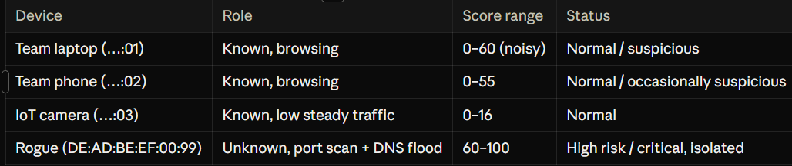

The injected rogue device ranged from 60 to 100 and reached high_risk and critical status, whereas the known laptop, phone and camera mostly stayed in the normal range. The camera’s low, steady traffic gave the lowest scores.

Risk-Score Breakdown for the Rogue Device
For the fully baselined rogue device the log shows the score reaching 100 with these reasons:

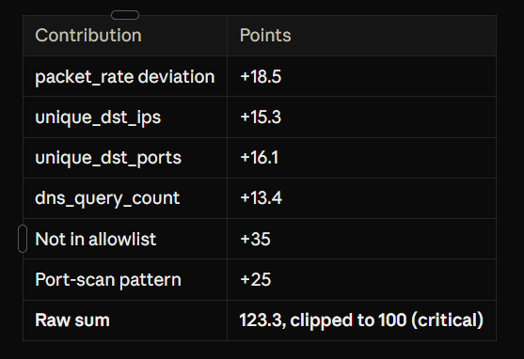

The resulting action was “isolate mac=DE:AD:BE:EF:00:99 ip=192.168.1.199 (dry-run)”. The 60-point lower bound of the rogue range equals the allowlist and port-scan penalties combined (35 + 25), so an unknown scanner is flagged high-risk even before behavioural deviation accumulates.

Qualitative Comparison with N-BaIoT:
The comparison is qualitative only; the two systems were not benchmarked on a common dataset.

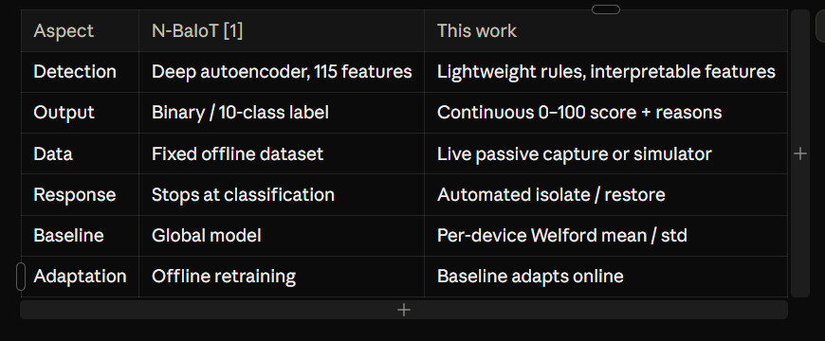

Discussion, Errors and Limitations:
The results show that the rule-based score separates an injected scanner from ordinary devices and that every point of the score is explainable, which is the main advantage over opaque learned models. The results are preliminary, and several limitations apply.
- Baseline noise (false positives). With only six learning windows, the per-feature standard deviation is a noisy estimate, so the simulated laptop sometimes reached suspicious or high-risk status on ordinary variance. Longer learning windows or a robust estimator such as the median absolute deviation (MAD) should stabilise the score.
- Evaluation scope. Traffic is synthetic, the run contains a single injected rogue device, and isolation was exercised only in dry-run mode. Accordingly, no accuracy, precision, recall, F1, detection latency or resource overhead is claimed.
- Baseline drift. Because the baseline adapts online, very slow drift could be absorbed into it. Freezing or slowing baseline updates while a device’s score is elevated is a natural safeguard.
- Spoofing and privacy. The allowlist penalty assumes device identities are not spoofed. The system works on traffic metadata (addresses, ports, DNS counts) and does not inspect payloads.

CONCLUSION AND FUTURE SCOPE
This project set out to detect rogue devices on a LAN from passive traffic. The approach combines per-device Welford baselining, an interpretable 0–100 risk score and an isolate–re-evaluate–restore loop, delivered as a working prototype with SQLite storage and a live dashboard. Objectives 1, 3 and 4 were achieved, objective 2 was achieved for the rule-based engine (the ML layer remains planned), and objective 5 was met at a preliminary, qualitative level. In a reproducible 90-second simulation the injected rogue device reached the critical score of 100 and triggered an isolation log, while the known devices mostly stayed normal, and all eight units tests pass. The most important limitation is baseline noise, which caused false positives on a legitimate device.
Future scope:
- Run live_capture.py on a controlled LAN with a mirrored or monitor-mode interface.
- Add more learning windows and a MAD-based robust estimator to reduce false positives.
- Layer a machine-learning anomaly score beside the rule engine as a second signal.
- Validate isolation and restoration beyond dry-run in an isolated testbed before enabling iptables enforcement.
- Run repeated attack and benign scenarios to report detection rate, false-positive rate, latency and overhead.
- Add drift and spoofing safeguards, such as slowing baseline updates while a score is elevated.

REFERENCES
Y. Meidan et al., “N-BaIoT—Network-based detection of IoT botnet attacks using deep autoencoders,” IEEE Pervasive Computing, vol. 17, no. 3, pp. 12–22, Jul.–Sep. 2018. https://arxiv.org/abs/1805.03409
C. Neumann, O. Heen and S. Onno, “An empirical study of passive 802.11 device fingerprinting,” arXiv:1404.6457, 2014. https://arxiv.org/pdf/1404.6457
A. Prasad, K. Biju, S. Somani and B. Mitra, “Context-aware behavioral fingerprinting of IoT devices via network traffic analysis,” in Proc. SECRYPT, 2023, pp. 335–344. https://www.scitepress.org/Papers/2023/120560
“Early-stage IoT device identification using passive network traffic analysis,” arXiv:2605.02449, 2026. https://arxiv.org/html/2605.02449v1. “Identification of IoT devices using neural networks and passive DNS traffic,” 2025. https://doi.org/10.3233/ATDE250715
“From flows to functions: Macroscopic behavioral fingerprinting of IoT devices via network services,” arXiv:2512.16348, 2025. https://arxiv.org/pdf/2512.16348
“SecuNet-4D: A comprehensive framework for distributed SDN security and resilience,” Scientific Reports, 2025. https://www.nature.com/articles/s41598-025-98649-x
“GeckoNet: Self-healing SDN framework,” ResearchGate, 2024. https://www.researchgate.net/publication/385191526
B. P. Welford, “Note on a method for calculating corrected sums of squares and products,” Technometrics, vol. 4, no. 3, pp. 419–420, 1962. https://doi.org/10.1080/00401706.1962.10490022
“Trackly: A unified platform for user behavior analytics and real-time rule-based anomaly detection,” arXiv:2601.22800, 2026. https://arxiv.org/pdf/2601.22800
“Fingerprint merging and risk-level evaluation for network anomaly detection,” U.S. Patent 10,320,825. [add patent URL]
“Autonomous threat detection and response in cloud security: A survey of AI-driven strategies,” arXiv:2601.03303, 2026. https://arxiv.org/pdf/2601.03303
“Self-healing AI-driven networks for automated cyber threat detection and recovery,” ResearchGate, 2025. https://www.researchgate.net/publication/396216006
“Towards security automation in software-defined networks,” Computer Communications, 2021. https://www.sciencedirect.com/science/article/abs/pii/S0140366421004436
Scapy documentation. https://scapy.net
Flask documentation. https://flask.palletsprojects.com
SQLite documentation. https://www.sqlite.org/docs.html
pytest documentation. https://docs.pytest.org

